**Physics**

***Final Review Packet***

Please note that the following chapters are meant to direct your studying.

**We did not cover every topic** in each of the listed section of the Physics Classroom.

**Unit 1 – Wave Motion**

**Physics Classroom:** Waves + Sound Waves & Music

**Key Vocab Words:**

wave, transverse wave, longitudinal wave, trough, crest, wavelength, frequency, principle of superposition,   
 interference, destructive interference, node, constructive interference, antinode, reflection, refraction,   
 diffraction, pitch, Doppler shift, resonance

**Problems:**

1. Identify the following images as one of the following: reflection, interference, diffraction or refraction.In addition, describe what each term means. **a) interference c) refraction**  [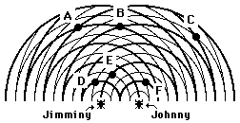](http://www.gcsescience.com/Diffraction-Water-Waves.gif) [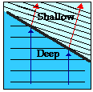](http://images.google.com/imgres?imgurl=http://www.paulfriedlander.com/images/timetravel/interference%20-1.jpg&imgrefurl=http://www.paulfriedlander.com/text/timetravel/experiment.htm&h=366&w=549&sz=81&hl=en&start=31&um=1&tbnid=lKJMnbc7eqIUpM:&tbnh=89&tbnw=133&prev=/images?q=wave+interference&start=20&ndsp=20&svnum=10&um=1&hl=en&sa=N)   
     **b) reflection d) diffraction** [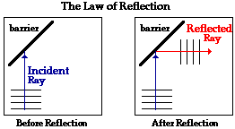](http://images.google.com/imgres?imgurl=http://steve.files.wordpress.com/2006/03/reflection%20on%20water.jpg&imgrefurl=http://steve.wordpress.com/2006/03/19/the-phyiscs-of-light-phenomena-part-i/&h=400&w=600&sz=42&hl=en&start=11&um=1&tbnid=9ugpQmLQ7uBSmM:&tbnh=90&tbnw=135&prev=/images?q=wave+reflection&svnum=10&um=1&hl=en) [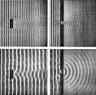](http://images.google.com/imgres?imgurl=http://www.school-for-champions.com/science/images/waveobstacle-refraction.gif&imgrefurl=http://www.school-for-champions.com/science/waveobstacle.htm&h=308&w=400&sz=18&hl=en&start=56&um=1&tbnid=KE_2AqJgIeNczM:&tbnh=95&tbnw=124&prev=/images?q=wave+refraction&start=40&ndsp=20&svnum=10&um=1&hl=en&sa=N)
2. If sound travels at 5600 m/s through a steel rod, what is the wavelength, given a wave frequency of 2480 Hz? 2.26m
3. The speed of a wave depends upon (i.e., is causally affected by)… a
   1. the properties of the medium through which the wave travels.
   2. the wavelength of the wave.
   3. the frequency of the wave.
   4. both the wavelength and the frequency of the wave.
4. Look at the image in problem 1, letter d.   
    a) What do the light bands represent? crests  
    b) What do the dark bands represent? troughs  
    c) What do the gray fuzzy lines represent? Nodal lines (regions of destructive interference)
5. What is the Doppler shift? Provide an example of a time when you experienced this phenomenon. See PCR
6. Ella Fitzgerald has the ability to break glass when she sings. Why does the glass shatter? resonance
7. **TRUE or FALSE –** In order for John to hear Jill, air molecules must move from the lips of Jill to the ears of John.
8. A sound wave is different than a light wave in that a sound wave is… b
   1. produced by an oscillating object and a light wave is not.
   2. not capable of traveling through a vacuum.
   3. not capable of diffracting and light wave is.
   4. Capable of existing with a variety of frequencies and a light wave has a single frequency.
9. 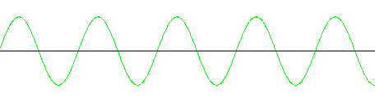Label the following diagram. Include these terms: amplitude, wavelength (all 3 ways to indicate wavelength), crest, trough. see PCR

**Unit 2 – Optics**

**Physics Classroom:** Light Waves & Color + Reflection…+ Refraction…

**Key Vocab Words:**

light, electromagnetic spectrum, primary color, secondary color, dye, pigment, primary pigment, secondary pigment,   
 polarized, reflection, refraction, angle of refraction, angle of incidence, plane (flat) mirrors, concave converging   
 mirrors, convex diverging mirrors, convex converging lens, concave diverging lens, real, virtual, inverted, upright.

**Problems:**

1. 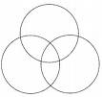Fill in the diagrams for the mixing of light and the mixing of pigments: See PCR  
   **Light Pigment**
2. How do you create cyan light? blue + green

1. Consider the visible light spectrum (ROYGBIV)...
   1. Which color has the greatest frequency? violet
   2. Which color has the greatest wavelength red
2. The diagrams depict a sheet of paper being illuminated with white light (ROYGBIV). The papers are impregnated with a chemical capable of absorbing one or more of the colors of white light. In each case, determine which color(s) of light are reflected by the paper and what color the paper will appear to an observer. See PCR  
     
    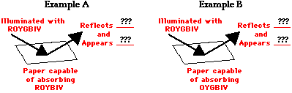
3. In the diagrams below, several sheets of paper are illuminated by different primary colors of light (R for red, B for blue, and G for green). Indicate what primary colors of light will be reflected and the appearance of the sheet of paper. (Note the similarity between this problem and the above problem.) See PCR

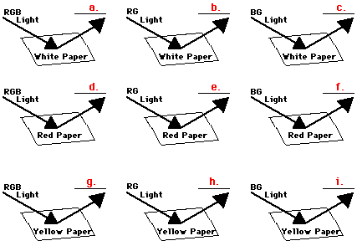

1. Answer the following questions as they pertain to mirrors:  
    a) Describe the physical properties of the image seen in a plane mirror. Virtual, same size, same distance  
    b) Describe the physical properties of a virtual image. Upright, can’t show up on screen  
    c) An object produces a virtual image in a concave mirror. Where is the object located? Behind (in) mirror   
    e) Describe the image seen in a convex (diverging) mirror. Small, closer than object, virtual

1. An object 2.4-cm high is placed 12.0 cm from a concave converging mirror with a focal point of 3.0 cm.  
    a) Draw a ray diagram. Use a ruler to mark   
      
    f and 2f at equal spacing. Object   
     
     
     
     
     
     
     
     
      
    b) Where will the image be located? 4cm
2. An object that is 4.0 cm high is placed 14.0 cm from a convex converging lens that has a focal length of 9.0 cm.  
    a) Draw a ray diagram. Use a ruler to mark  
    f and 2f at equal spacing.  
     
     
     
    b) Where will the image be located?  
   25.2 cm

**Unit 3 – Electrostatics**

**Physics Classroom:** Static Electricity

**Key Vocab Words:**

electrostatics, neutral, insulator, conductor, electroscope, charging by friction, charging by conduction,   
 charging by induction, grounding, electric field, electric field lines

**Problems:**

1. Describe the steps one would take to charge an object by each of the following ways: friction, conduction, and induction. See PCR
2. **TRUE or FALSE** – An object that is positively charged contains all protons and no electrons.
3. **TRUE or FALSE** – An object that is negatively charged could contain only electrons with no accompanying protons.
4. **TRUE or FALSE** – An object that is electrically neutral contains only neutrons.
5. A physics student is investigating the charge on several objects and makes findings below. The student knows that object **A is negatively charged and object B is electrically neutral.** What can be concluded about the charge on objects C, D, E and F? (C=negative; D=negative; E=positive; F=positive)

|  |  |  |  |
| --- | --- | --- | --- |
| **Object C** | **Object D** | **Object E** | **Object F** |
| attracts B | repels C | attracts D  repels F | attracts A |

1. A rubber balloon possesses a positive charge. If brought near and touched to the door of a wooden cabinet it sticks to the door. This does not occur with an uncharged balloon. Explain what happens to allow the balloon to stick. The door becomes polarized (electrons drawn toward the balloon) then the balloon and door are attracted to each other.